ARTIFICIAL INTELLIGENCE (AI) BASICS
How AI Learns from Data and Patterns
Class 7 Notes | Learn how data and patterns make AI smart
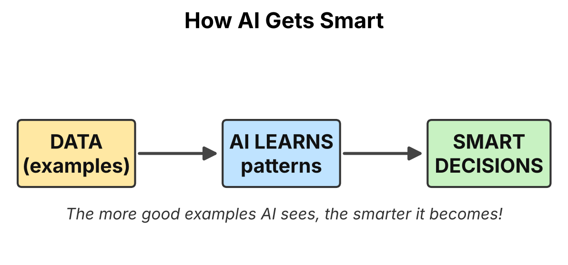
Figure 1: AI learns patterns from data and then makes smart decisions.
What you will learn
1. What AI is and what data is
2. What a pattern is
3. How AI uses data and patterns to learn
4. Examples of AI around us
5. Why good data is important

1. What is Artificial Intelligence (AI)?
A computer normally follows exact instructions written by a person. Artificial Intelligence (AI) is different. It is a way of making computers and machines learn, think and make decisions in a smart way, a little like humans do.
Humans become smart by learning from experience. A child learns what a dog looks like by seeing many dogs. In the same way, AI becomes smart by learning from many examples. These examples are called data.
Remember
Human brain: learns from experiences.
AI: learns from data.

2. What is Data?
Data means facts and information that can be collected, stored and used. Data is the food of AI. Without data, AI cannot learn anything.
Data can come in many forms:
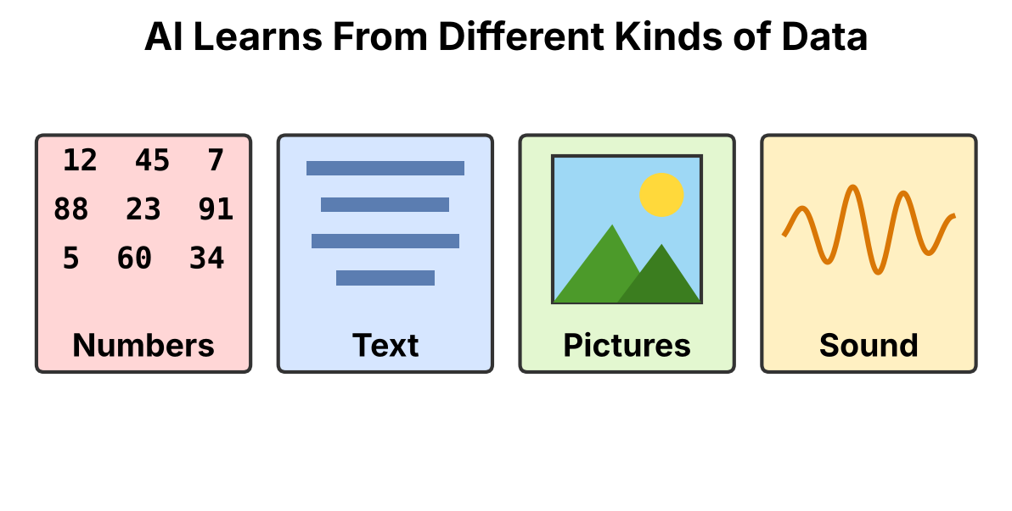
Figure 2: Different kinds of data that AI can learn from.
Type of data | Example | What AI can learn
Numbers | Marks of students, temperature | Predict results or weather
Text | Messages, books, reviews | Understand language, translate
Pictures | Photos of animals, faces | Recognise objects and faces
Sound | Voice, songs | Understand speech, voice commands

3. What is a Pattern?
A pattern is something that repeats or follows a rule. When we look at lots of data carefully, we can spot things that are similar or that happen again and again.

Patterns in daily life
- Every day the sun rises in the morning and sets in the evening.
- Number pattern: 2, 4, 6, 8, ... The next number is 10 (we add 2 each time).
- Your school bell rings at the same times every day.
- Bananas are long, yellow and curved, while apples are round.

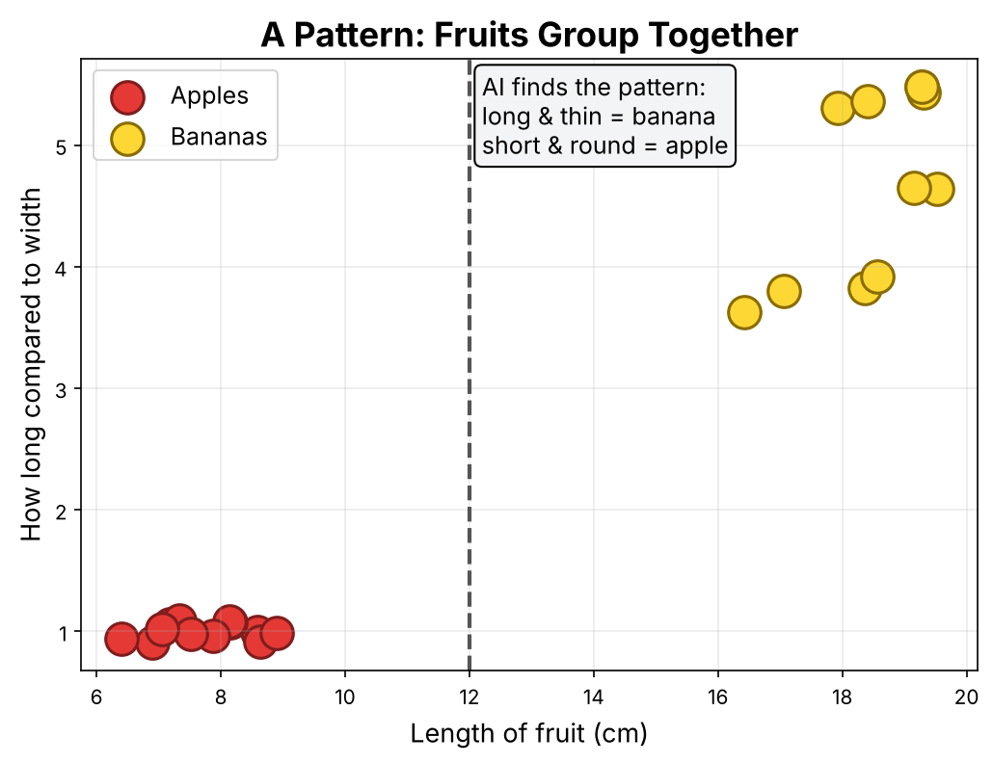
Figure 3: AI looks at many fruits and finds a pattern that separates apples from bananas.
Key idea: AI does not memorise every example. It finds the pattern hidden in the data and then uses that pattern on new things it has never seen.

4. How Does AI Learn from Data?
AI learns step by step, like a student who practises and corrects mistakes. This is called training the AI.
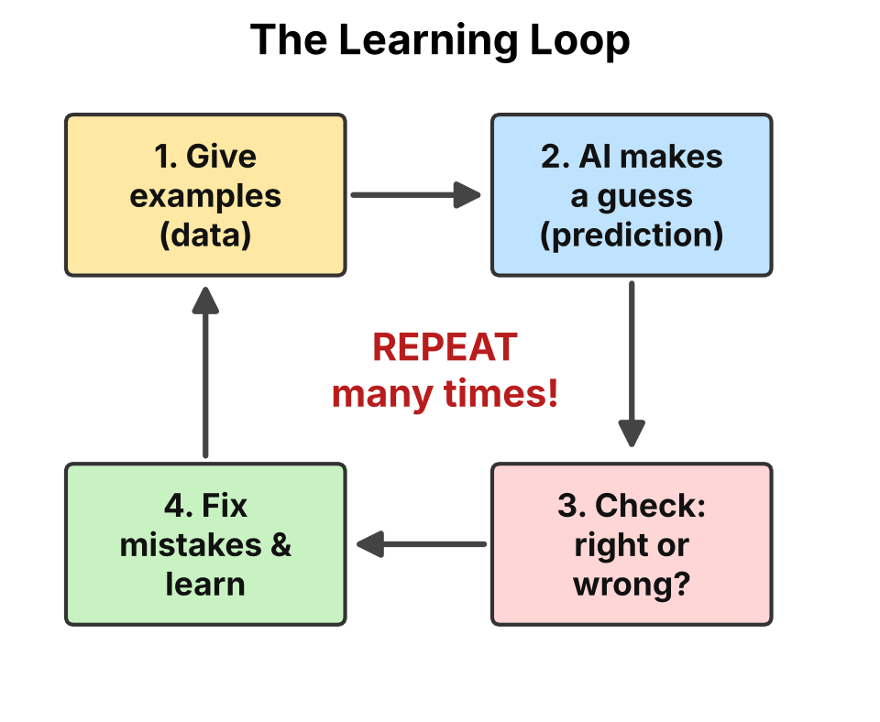
Figure 4: The learning loop. AI repeats these steps again and again.
- Give examples (data). We show the AI thousands of examples.
- AI makes a guess. It tries to find a pattern and predict an answer.
- Check the answer. The answer is compared with the correct one.
- Learn from mistakes. If the guess is wrong, the AI adjusts itself and tries again.

After many rounds of practice, the AI makes fewer mistakes. It has become smart!

5. Example: Teaching AI to Recognise Cats and Dogs
Stage | What happens
Step 1 | We collect thousands of photos. Each photo is labelled 'cat' or 'dog'.
Step 2 | The AI studies the photos and notices patterns: cats often have pointed ears and whiskers; dogs have longer noses and floppy ears.
Step 3 | The AI guesses on new photos. Sometimes it is wrong, so it corrects itself.
Step 4 | After lots of practice, we show a brand new photo. The AI correctly says 'This is a dog!'

Think about it
If we only showed the AI pictures of white cats, would it recognise a black cat? Probably not! AI needs many different examples to learn well.

6. AI Around Us: Learning from Data
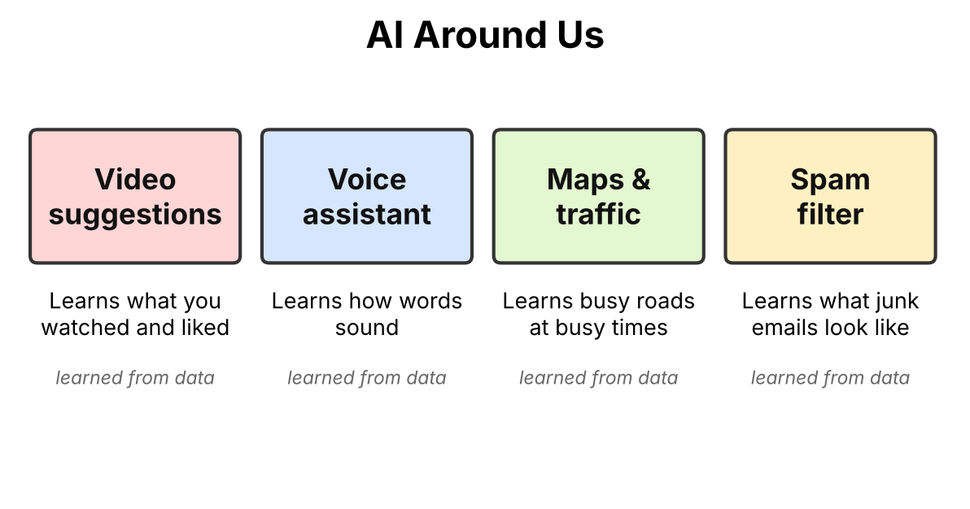
Figure 5: Everyday examples of AI that learn from data.
- Video suggestions: AI notices which videos you watch and like, then suggests similar ones.
- Voice assistants: AI learns from thousands of voices how words sound, so it can understand you.
- Maps and traffic: AI learns which roads are busy at which times and suggests the fastest route.
- Spam filter: AI learns what junk emails look like and keeps them out of your inbox.

7. Why Good Data is Important
AI is only as smart as the data it learns from. If the data is wrong or unfair, the AI will also make wrong or unfair decisions. Computer experts say: "Garbage in, garbage out."
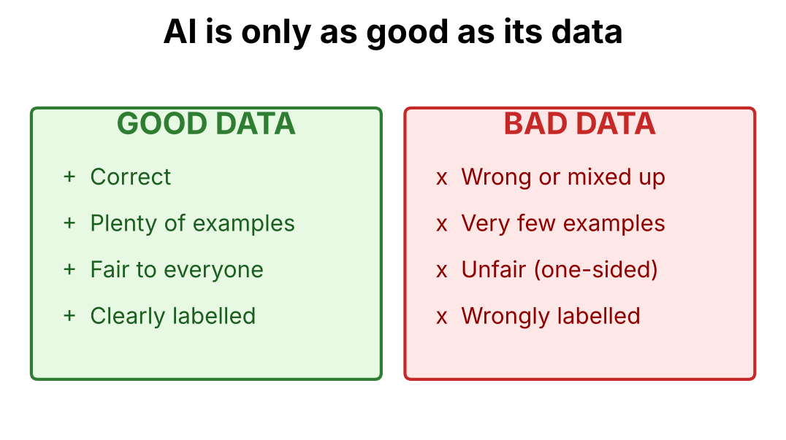
Figure 6: Good data helps AI learn well. Bad data confuses it.
Example: If a child is taught that a cat is called a 'dog', the child will always call cats dogs. AI is the same. Wrong labels in the data lead to wrong answers.

8. Three Ways AI Can Learn
Just like students learn in different ways, AI can also learn in different ways. At your level, it is enough to know these three big ideas.
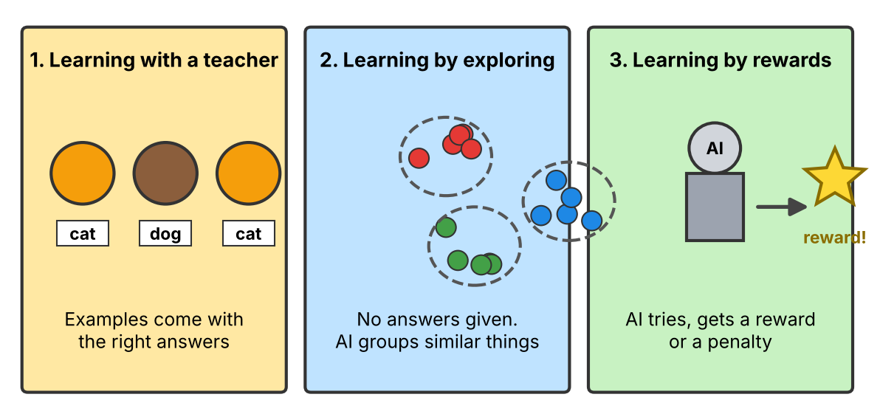
Figure 7: Three ways in which AI can learn.
Way of learning | How it works | Everyday example
1. Learning with a teacher | Every example comes with the correct answer (a label). The AI compares its guess with the answer. | Photos labelled 'cat' or 'dog'; emails marked 'spam' or 'not spam'.
2. Learning by exploring | No answers are given. The AI looks for things that are alike and puts them in groups. | A shop app groups customers who buy similar things.
3. Learning by rewards | The AI tries something. A good result gives it a reward, a bad result gives a penalty. It slowly learns what works. | A computer learning to play a video game by playing again and again.

Did you know?
A game-playing AI can play millions of games in a short time. That is much more practice than any human can do, which is why it can become very good.

9. How a Computer Sees a Picture
When you look at a photo, you see a face, a tree or a heart. A computer does not see like we do. It sees only numbers.
Every picture is made of tiny dots called pixels. Each pixel has a number that tells the computer its colour or brightness. In the simple heart below, 1 means a coloured square and 0 means a white square.
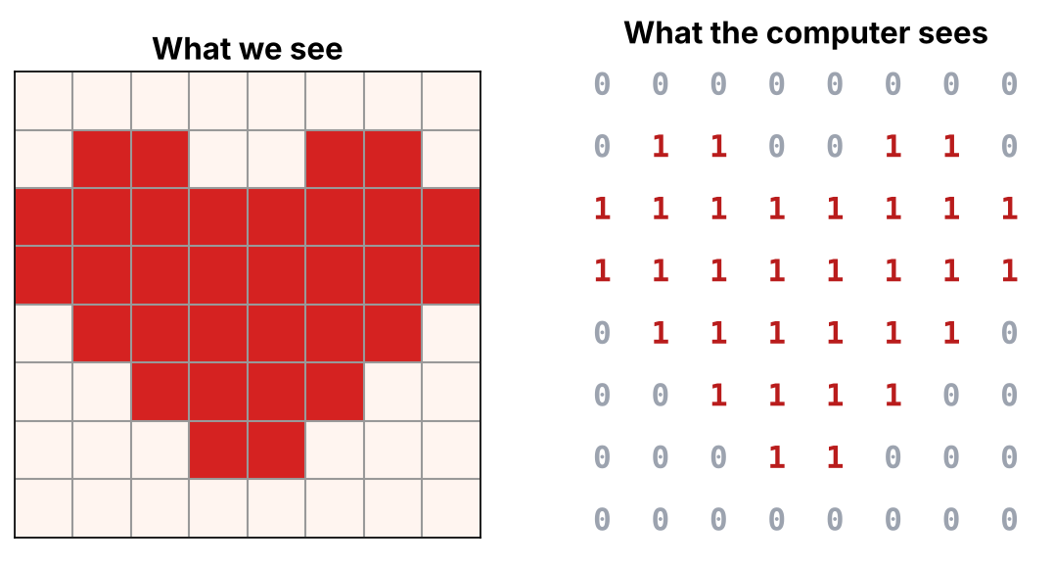
Figure 8: A picture is stored as numbers. The AI learns patterns in these numbers.

What does the AI do with these numbers?
- It looks at the numbers of thousands of pictures.
- It finds patterns. For example, the numbers for a heart always make a certain shape.
- When it gets a new picture, it compares the numbers with the patterns it has learned and decides what the picture shows.
Remember
Pictures, sounds and words are all turned into numbers before an AI can learn from them.

10. Human Learning and AI Learning
Humans and AI both learn from examples, but there are important differences.
 | Humans | AI
What we learn from | Experience, books, teachers, family, feelings | Data given by people
Speed | Slow, one thing at a time | Very fast, can study millions of examples
Tiredness | Gets tired and needs rest | Does not get tired
Understanding | Understands feelings, kindness and meaning | Only finds patterns; does not truly feel or understand
Creativity and common sense | Strong | Limited; depends on what it has seen
Mistakes | Can learn from a single mistake | Needs many examples to correct a mistake

Key idea: AI is a helper, not a replacement for people. Humans decide what to teach AI and check whether its answers are right.

11. What AI Can and Cannot Do
AI can do well | AI cannot do well
Find patterns in huge amounts of data | Understand feelings like a human friend
Work quickly without getting tired | Use common sense in new situations
Recognise faces, voices and objects | Know if its own data is wrong or unfair
Suggest videos, songs and routes | Take responsibility for its decisions
Translate languages and answer questions | Learn well from very few examples

Think about it
If an AI has only seen pictures of dogs in the daytime, will it recognise a dog at night? Why or why not?

12. Using AI Safely and Responsibly
AI is a powerful tool. Like any tool, we must use it wisely and kindly. Here are some golden rules for students.
- Protect your privacy. Never share your full name, address, phone number, passwords or photos with an AI app or website without a trusted adult's permission.
- Check the answer. AI can make mistakes. Always confirm important facts from a book, a teacher or a trusted website.
- Do your own thinking. Use AI to help you learn, but do your homework and thinking yourself. Copying AI answers does not make you smarter.
- Be fair and kind. Never use AI to make fun of, trick or hurt anyone.
- Ask an adult. If something online or from an AI makes you feel uncomfortable, tell a parent or teacher.

Bias alert
If the data given to an AI is one-sided, its decisions will be one-sided too. That is why people must collect fair data that represents everyone.

13. A Short Timeline of AI
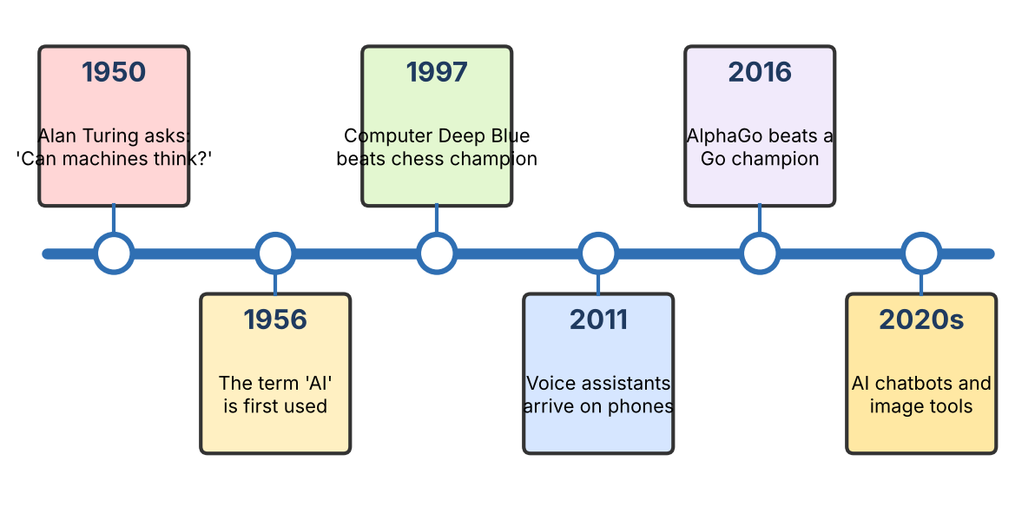
Figure 9: Some important moments in the story of AI.
AI has grown step by step. As computers became faster and as more data became available, AI became better at learning patterns. Today you meet AI every day in phones, apps, maps and games.

14. Quick Summary
Key Points to Remember
• AI is a way of making machines learn and make smart decisions.
• Data is the information (numbers, text, pictures, sound) that AI learns from.
• A pattern is something that repeats or follows a rule.
• AI finds patterns in data, makes guesses, checks, and improves by practice.
• The more good data AI sees, the smarter it becomes.
• Bad or unfair data makes AI make mistakes.
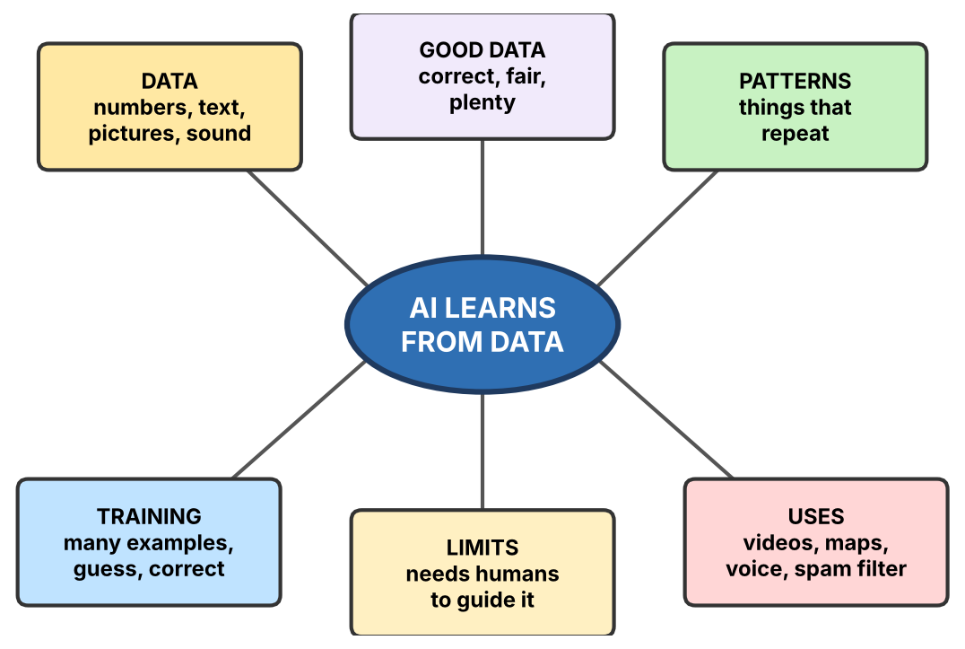
Figure 10: Mind map of the whole chapter.

15. Important Words (Glossary)
Word | Meaning
Artificial Intelligence | Machines that can learn, think and make decisions like humans.
Data | Facts and information such as numbers, text, pictures and sound.
Pattern | Something that repeats or follows a rule.
Training | Teaching AI by showing it lots of examples.
Prediction | A smart guess made by the AI based on what it has learned.
Label | The correct name given to an example, like 'cat' on a cat photo.

16. Practice Questions

A. Fill in the blanks
- AI learns from ________ (data / sleep).
- Something that repeats or follows a rule is called a ________.
- Teaching an AI using examples is called ________.
PART 2: ACTIVITIES
Learn by doing! Try these in class or at home

Activity 1: Pattern Detective
Goal
Find patterns, just like AI does.

What you need: pencil and coloured pencils.
- Look at each row of shapes.
- Find the pattern that repeats.
- Draw the shape that comes next in the box with a ?.
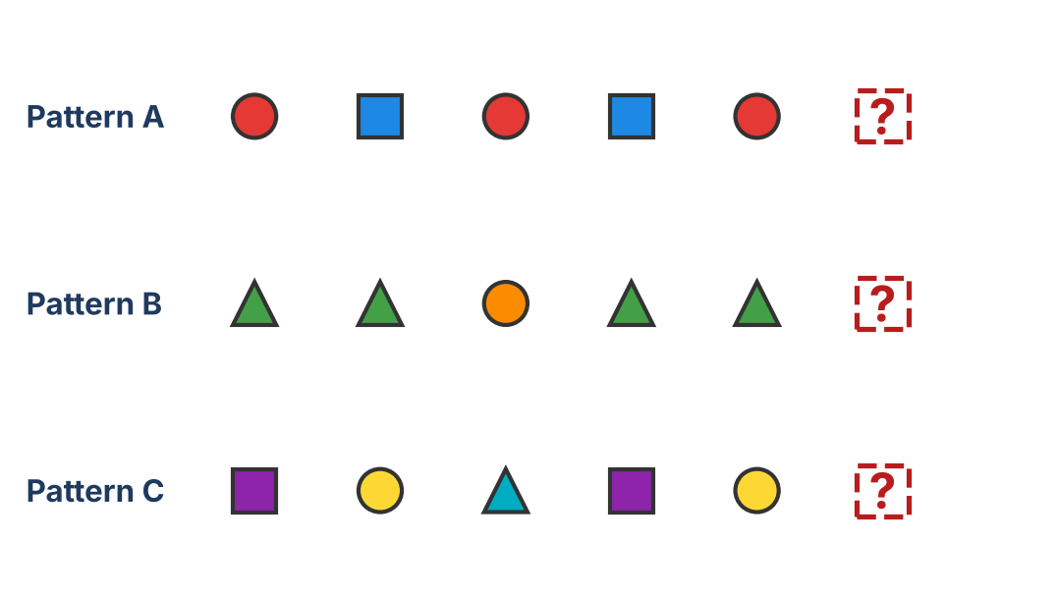
Figure 11: Find the missing shape in each pattern.
Now you make one! Draw your own pattern with shapes or colours in the space below. Ask a friend to find the next one.

Think: How did you find the answer? You looked at many examples, spotted what repeats and then made a prediction. That is exactly how AI learns!

Activity 2: Be the AI! (Class Game)
Goal
Understand training and learning from mistakes.

Play in groups of 4. One student is the Trainer and the others are the AI.
- The Trainer secretly thinks of a rule, for example: "Words that start with the letter B are YES. All other words are NO."
- The Trainer shows 6 example words and tells the AI if each one is YES or NO (this is the training data).
- The AI group discusses and tries to guess the secret rule (finding the pattern).
- The Trainer says 3 new words. The AI predicts YES or NO. The Trainer tells them right or wrong.
- If the AI was wrong, it changes its rule and tries again. Swap roles and play again.

Score card: fill this in while you play.
Round | Word shown | AI's guess (YES/NO) | Right or wrong? | Points
1
2
3
4
5

Discuss: Did more examples make it easier to guess the rule? What happened when the examples were too few?

Activity 3: Sort the Data
Goal
See how features (clues) help AI put things into groups.

Read the clues about each animal. Decide if it is a BIRD or a MAMMAL, then write the clue that helped you. This is called finding a pattern in data.
Animal | Clues (features) | Bird or Mammal? | Clue that helped me
Sparrow | Has feathers, lays eggs, can fly
Cow | Has fur, gives milk, 4 legs
Parrot | Has feathers, beak, lays eggs
Dog | Has fur, gives birth to puppies
Bat | Has fur, gives milk, can fly
Penguin | Has feathers, lays eggs, cannot fly
Goat | Has fur, gives milk, 4 legs
Crow | Has feathers, beak, can fly

Challenge: A bat can fly, but is it a bird? What does this teach you about patterns? (Hint: one clue is not enough. AI needs many clues!)

Make your own sorting table
Choose two groups (for example fruits and vegetables, or day and night animals). Write 4 examples and 2 clues for each in your notebook.

Activity 4: Good Data or Bad Data?
Goal
Understand why careful, correct data is important.

Imagine a fruit-recognising AI. Write GOOD or BAD for each kind of data and explain why.
Training data given to the AI | Good / Bad | Why?
1000 photos of apples, all correctly labelled 'apple'
10 photos of bananas, 5 of them labelled 'mango'
Photos of only red apples, nothing else
Apples, bananas and mangoes in many colours and sizes, all correctly labelled
Blurry photos where nothing can be seen clearly

Fix the data
Pick one BAD row from the table. Write how you would improve the data so that the AI can learn properly.

Class discussion
Why do you think a phone's face unlock needs photos of faces in different light, with and without glasses?

Activity 5: Pixel Artist
Goal
Understand that a computer stores pictures as numbers.

Colour the squares of the grid using the instructions. The columns are numbered 1 to 8 and the rows are lettered A to H.
Row A | Row B | Row C | Row D | Row E | Row F | Row G | Row H
none | 2, 3, 6, 7 | all 8 | all 8 | 2 to 7 | 3 to 6 | 4, 5 | none

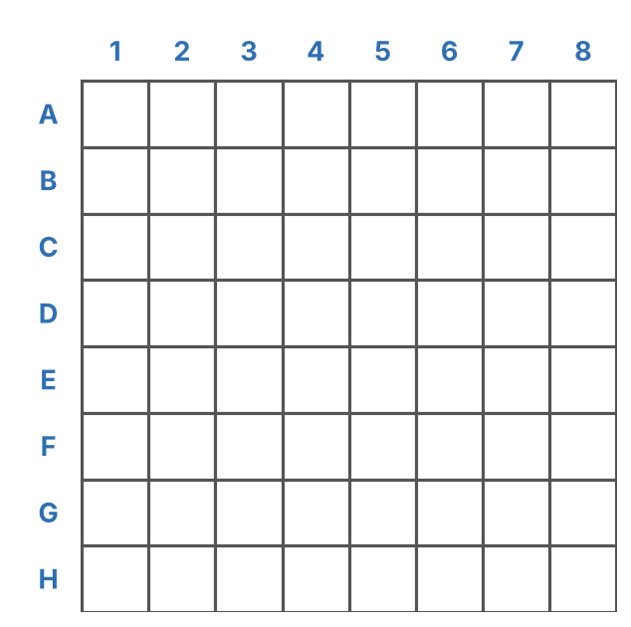
Figure 12: Colour the squares to reveal the picture.
Now write the code! Write 1 for a coloured square and 0 for a white square. Row B is done for you.
Row | Numbers (columns 1 to 8)
A
B | 0 1 1 0 0 1 1 0
C

What did you draw? Compare with Figure 8 in Chapter 9. This is how a computer sees a picture!

Activity 6: Class Survey
Goal
Collect data and find a pattern in it.

Ask 8 classmates the questions below and fill in the table. This is your data.
Classmate | Favourite subject | Favourite game | Favourite fruit
1
2
3
4
5
6
7
8

Find the patterns
- Which subject, game and fruit were chosen the most?
- Which was chosen the least?
- Suppose a new student joins. Based on your data, what would you predict is their favourite fruit? Why?

Connect it: A music app does the same thing with thousands of users to guess what song you may like next.

Activity 7: Spot the AI
Decide whether each thing uses AI that learns from data. Write YES or NO and give a reason.
Thing | Uses AI? (YES/NO) | Reason
Torch
Phone face unlock
Simple calculator
Video app that suggests videos
Ceiling fan
Voice assistant
Email spam filter
Bicycle
Hint: If a machine only follows fixed steps, it is not using AI. If it improves by learning from data, it is using AI.

Activity 8: Mini Project: My AI Poster
Make a chart or poster on A3 paper titled "How AI Learns from Data". Work alone or in a group of 3.

Your poster must have
- A title and your name.
- A drawing of the learning loop (examples, guess, check, learn).
- Three examples of data (numbers, pictures, sound, text) with small drawings.
- One everyday example of AI learning from data.
- Two rules for using AI safely.

Checklist and marks
Poster feature | Marks | Marks you got
Correct ideas about data and patterns | 5
Learning loop is clear | 5
Neat drawings and colours | 5
Examples and safety rules | 5
Total | 20
PART 3: WORKSHEETS
Practise what you have learned

Worksheet 1: Multiple Choice Questions
Name: ______________________ Class: ________ Date: ____________
Circle the correct answer.
- AI learns mainly from ______.
a) sleep b) data c) food d) colours
- Something that repeats or follows a rule is called a ______.
a) pattern b) problem c) program d) picture
- Which of these is an example of data?
a) A photo b) A list of marks c) A recorded voice d) All of these
- Showing AI many examples so that it can learn is called ______.
a) cooking b) training c) drawing d) deleting
- If the data is wrong, the AI will ______.
a) always be right b) make mistakes c) switch off d) become faster
- The tiny dots that make up a picture on a computer are called ______.
a) pixels b) pencils c) pages d) pockets
- Examples that come with the correct answers are called ______ data.
a) lost b) labelled c) loud d) light
- Which of these should you NOT share with an AI app?
a) A school subject b) A joke c) Your home address d) A favourite colour
- Which is a good habit when using AI?
a) Believe every answer b) Check important facts c) Copy all homework d) Share passwords
- AI that tries again and again and gets a reward learns by ______.
a) exploring b) rewards c) copying d) sleeping

Worksheet 2: True or False
Name: ______________________ Class: ________ Date: ____________
Write T for True or F for False. If the statement is false, write the correct statement.
Statement | T / F | Correct statement (if false)
AI can learn from pictures, sound, numbers and text.
AI never makes mistakes while learning.
The more good examples AI sees, the smarter it becomes.
A pattern never repeats.
Unfair or wrong data can make AI take wrong decisions.
A computer sees a picture as numbers.
AI understands feelings exactly like humans.
We should always check important answers given by AI.
AI can learn without any data at all.
Humans decide what data to give to the AI.

Worksheet 3: Match the Following
Name: ______________________ Class: ________ Date: ____________
Write the correct letter from Column B in the Answer box.
Column A | Answer | Column B
1. Data |  | A. Something that repeats or follows a rule
2. Pattern |  | B. A smart guess made by AI
3. Training |  | C. Facts and information, such as numbers and pictures
4. Prediction |  | D. Teaching AI with many examples
5. Pixel |  | E. The correct name given to an example
6. Label |  | F. A tiny dot that makes up a picture
7. Reward |  | G. A prize that tells AI it did well
8. Bias |  | H. Unfair, one-sided results from poor data

Match the AI to its job
AI tool | Answer | What it learns
1. Spam filter |  | A. Which roads are busy at which times
2. Maps app |  | B. How words sound when people speak
3. Voice assistant |  | C. Which videos you may enjoy
4. Video suggestions |  | D. What junk emails look like

Worksheet 4: Label and Complete
Name: ______________________ Class: ________ Date: ____________

A. Label the diagram
Write the correct name under each box: DATA, SMART DECISIONS, AI LEARNS PATTERNS.
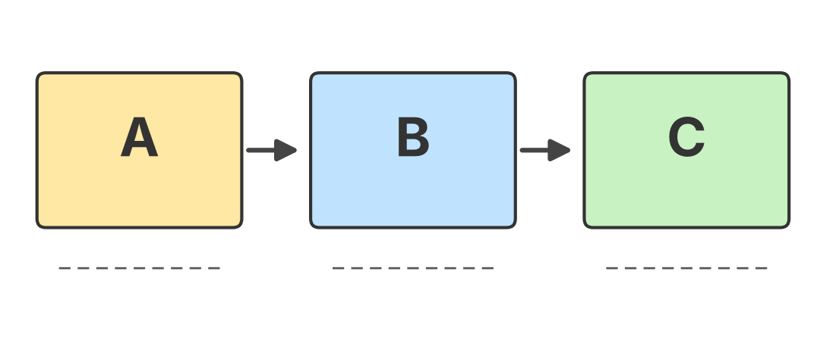
Figure 13: Label A, B and C.

B. Fill in the blanks using the words in the box
Word box
data pattern training pixels labels mistakes

- AI learns from ____________.
- A ____________ is something that repeats or follows a rule.
- Showing AI lots of examples is called ____________.
- Pictures are made of tiny dots called ____________.
- Correct names given to examples are called ____________.
- AI gets better by fixing its ____________.

Worksheet 5: Short Answer and Think
Name: ______________________ Class: ________ Date: ____________
- In your own words, what is a pattern? Give one example from daily life.

- Describe the four steps in how AI learns.

- A music app suggests songs you like. How do you think it learns what you like?

- Why is good data important for AI? Explain with an example.

- Complete the number patterns: (a) 5, 10, 15, 20, __, __ (b) 1, 4, 9, 16, __, __
- Write two safety rules for using AI.

Worksheet 6: AI Word Search
Name: ______________________ Class: ________ Date: ____________
Find the 10 hidden words. They run across, down or diagonally (top-left to bottom-right). Circle each word and tick it in the list.
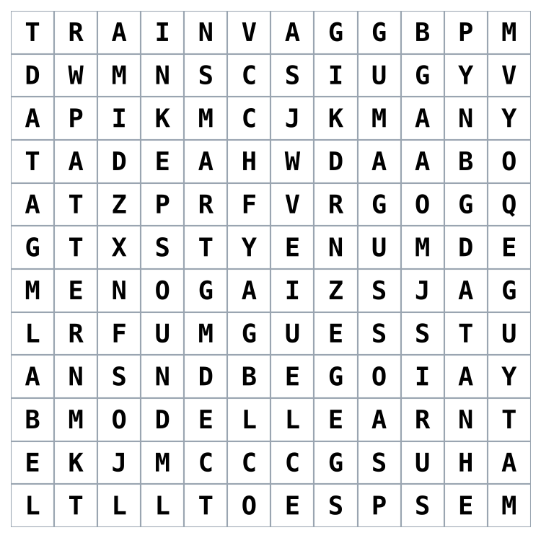
Figure 14: Find the hidden words.
Words
DATA | PATTERN | LEARN | TRAIN
GUESS | LABEL | IMAGE | SOUND
MODEL | SMART

Bonus: Choose any 3 words and write a sentence about AI using each of them.

Worksheet 7: Data Detective
Name: ______________________ Class: ________ Date: ____________
A teacher collected data about how many hours seven students studied and the marks they scored out of 100.
Student | Asha | Bala | Charu | Dev | Esha | Farid | Gita
Hours studied | 1 | 2 | 3 | 4 | 5 | 2 | 6
Marks scored | 45 | 55 | 65 | 72 | 85 | 52 | 90
- What pattern do you see between hours studied and marks scored?

- Which student studied the most? What were the marks?

- A new student, Hari, studies for 4 hours. Predict his marks. Give a reason.

- Is this prediction 100% sure? Why or why not?

Worksheet 8: Case Study: Meera's Music App
Read the story
Meera uses a music app. At first, the app played random songs. After a few weeks, it began suggesting songs that Meera really liked. The app noticed that she often played cheerful songs in the morning and slow songs at night. One day, Meera's brother used her phone to play loud rock songs for an hour. The next day, the app suggested many rock songs to Meera, but she did not like them.
- What data did the app use to learn about Meera?

- What pattern did the app find in Meera's listening?

- Why did the app suggest rock songs the next day? Was the data good or bad? Explain.

- How can the app improve its suggestions?

- What should the app do to protect Meera's privacy?

Revision Test (20 Marks)
Name: ______________________ Class: ________ Date: ____________

Section A: Choose the correct answer (5 x 1 = 5)
- AI becomes smart by learning from ______.
a) data b) toys c) sleep d) magic
- Something that repeats is a ______.
a) pixel b) pattern c) label d) reward
- Teaching AI with examples is ______.
a) training b) painting c) typing d) running
- A computer sees a picture as ______.
a) colours only b) feelings c) numbers d) sounds
- Bad or unfair data can cause ______.
a) wrong decisions b) faster speed c) more memory d) nothing

Section B: Fill in the blanks (5 x 1 = 5)
- The tiny dots that form a picture are called ____________.
- The four steps of AI learning repeat many ____________.
- Correct names given to examples are called ____________.
- Never share your ____________ with an AI app without permission.
- AI is only as good as its ____________.

Section C: Short answers (3 x 2 = 6)
- What is data? Give two examples.

- Write the four steps of the learning loop.

- Give two examples of AI that you use in daily life.

Section D: Long answer (1 x 4 = 4)
- Explain how AI learns to tell cats from dogs. Use the words data, pattern and training.

Answer Key (for Teachers and Parents)
Section | Answers
Chapter 16 Practice: Fill in the blanks | 1. data 2. pattern 3. training
Activity 1: Pattern Detective | A: blue square (square and circle take turns) B: orange circle (two triangles, then a circle, repeating) C: cyan triangle (square, circle, triangle repeat)
Activity 2: Be the AI | Answers depend on the secret rule chosen by the Trainer. Check that the AI group changed its rule after a wrong guess.
Activity 3: Sort the Data | Sparrow: Bird Cow: Mammal Parrot: Bird Dog: Mammal Bat: Mammal (fur, gives milk) Penguin: Bird Goat: Mammal Crow: Bird. Challenge: a bat flies but is a mammal, so one clue is not enough.
Activity 4: Good or Bad Data | 1. Good 2. Bad (wrong labels, too few) 3. Bad (only one kind, unfair) 4. Good (varied and correct) 5. Bad (unclear photos)
Activity 5: Pixel Artist | A: 0 0 0 0 0 0 0 0 C: 1 1 1 1 1 1 1 1 D: 1 1 1 1 1 1 1 1. The picture is a heart.
Activity 6: Class Survey | Answers depend on the class. Check that the predictions are based on the most common choice.
Activity 7: Spot the AI | Torch: NO Face unlock: YES Calculator: NO Video suggestions: YES Ceiling fan: NO Voice assistant: YES Spam filter: YES Bicycle: NO
Worksheet 1: MCQ | 1-b 2-a 3-d 4-b 5-b 6-a 7-b 8-c 9-b 10-b
Worksheet 2: True/False | 1-T 2-F 3-T 4-F 5-T 6-T 7-F 8-T 9-F 10-T
Worksheet 3: Match | 1-C 2-A 3-D 4-B 5-F 6-E 7-G 8-H. AI tools: 1-D 2-A 3-B 4-C
Worksheet 4: Label and Complete | A = DATA B = AI LEARNS PATTERNS C = SMART DECISIONS. Blanks: 1. data 2. pattern 3. training 4. pixels 5. labels 6. mistakes
Worksheet 5 | Q5: (a) 25, 30 (add 5 each time) (b) 25, 36 (square numbers). Other answers: accept sensible answers in the student's own words.
Worksheet 6: Word Search | Positions given as (row, column) of the first letter. DATA (2,1) down; PATTERN (3,2) down; LEARN (10,7) across; TRAIN (1,1) across; GUESS (8,6) across; LABEL (8,1) down; IMAGE (2,8) diagonal down-right; SOUND (6,4) down; MODEL (10,2) across; SMART (2,5) down.
Worksheet 7: Data Detective | 1. More hours of study gives higher marks. 2. Gita, 6 hours, 90 marks. 3. About 70 (between 65 and 72, close to Dev's 72). 4. No, it is only a prediction; other things also affect marks.
Worksheet 8: Case Study | 1. Songs she played and when. 2. Cheerful songs in the morning, slow songs at night. 3. Her brother's rock songs were mixed into her data, so it was bad data. 4. Use more data and ignore songs played by other people. 5. Keep her data private and ask permission.
Revision Test | A: 1-a 2-b 3-a 4-c 5-a. B: 1. pixels 2. times 3. labels 4. personal details (password, address) 5. data. C and D: award marks for correct ideas in the student's own words.

